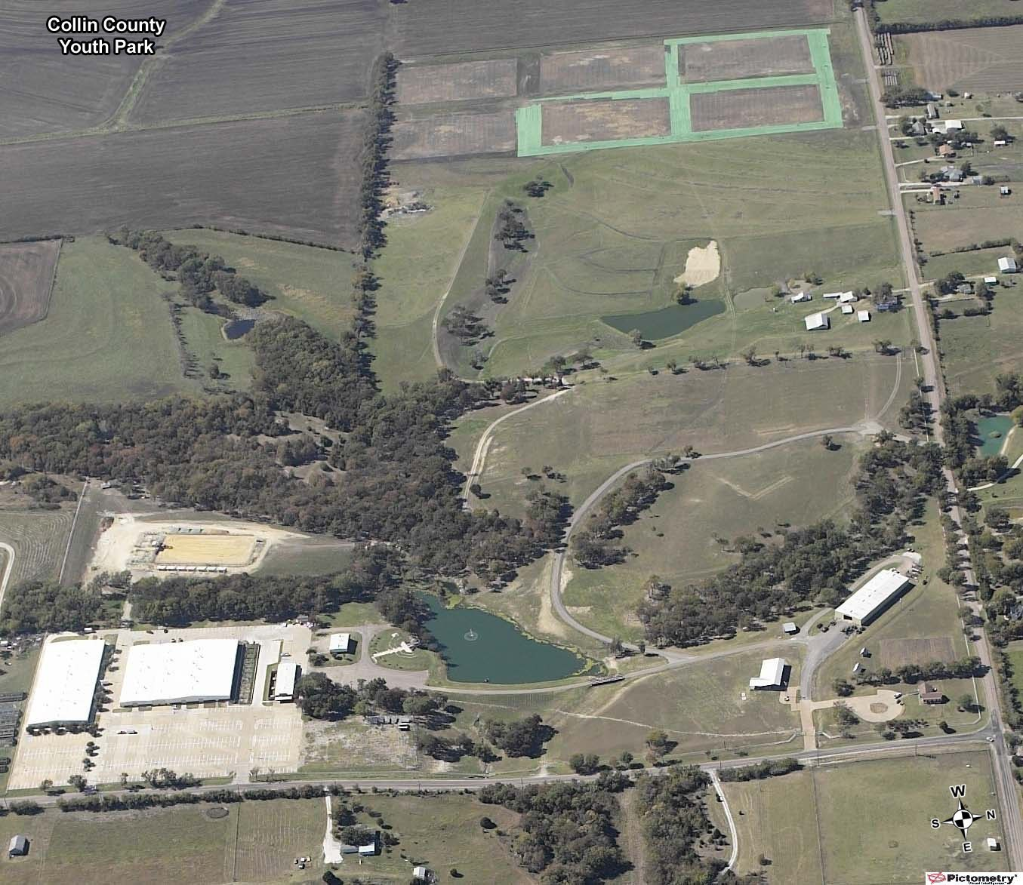

Public Parking

2M

The course will start and make the small east loop first (bottom of this map- solid line). The course will run up towards the west end of the park and make a larger loop (top of this map - dashed line). The course finishes with another smaller loop at east end of park into the finish. (dashed line)

Finish

1M

**5K Course**

Start